

**Trimester: I/II/III Subject: Programming and Problem Solving**

**Name**: Krishnaraj Thadesar **Division:** 9

**Roll No.:** 109054 **Batch:** I3

**Experiment No.:** 6

**Name of the Experiment:** Factorial using Recursion

**Performed on:** 3rd February 2022

**Submitted on:** 21st January 2022

**AIM**: Write an algorithm and draw a flowchart for a C program to find the factorial of a number using recursion.

**OBJECTIVE:**

1. To learn and understand arrays in C.
2. To learn and understand two dimensional arrays and operation on it.

**THEORY:**

*What is an Array?*

An Array is a collection of similar type of data items stored at contiguous memory locations. It is a variable that can store multiple values.

*Types of Arrays:*

1. *One Dimensional Array:*

In C programming language, one dimensional arrays are used tos teore a list of values of the same data type.

Eg. Int marks[2] = {99, 98};

1. *Two Dimensional Array*: An array having more than one dimensions is known as a multi-dimensional array. If the array has 2 dimensions, it is known as a two dimensional array.

Eg. int matrix[2][2] = {

{1, 2}

{2. 3}

}

1. *Multi-dimensional Arrays*: An array having more than one dimensions is known as a multi-dimensional array

*Declaration of a 1D Array*

1. The declaration must have a data type (int, char, float, double, etc), variable name, and square brackets with the number of elements of the array inside it.
2. Subscript or the square brackets represents the size of the array.
3. Array index always starts from 0
4. Each element in stored in a separate memory location.

*Declaration of a 2D Array*

Syntax: data_type array-name[row-size][col-size]

Initialization: int matrix[2][2] = {

{1, 2}

{2. 3}

}

# PLATFORM: *Windows 11 64 Bit*

# ALGORITHM:

Step 1: Start

Step 2: Declare 3 Matrices of Size [3][3] each and assign them to zero.

Step 3: Input the First Matrix

Step 4: Input the Second Matrix

Step 5: Write another nested For loop

Step 6: Switch the Choice variable inside the for loop

Step 7: If choice is 1, add the values, if choice is 2, subtract the values and assign them to the third matrix C.

Step 6: Output the Third Matrix

Step 7: End

# Flowchart:

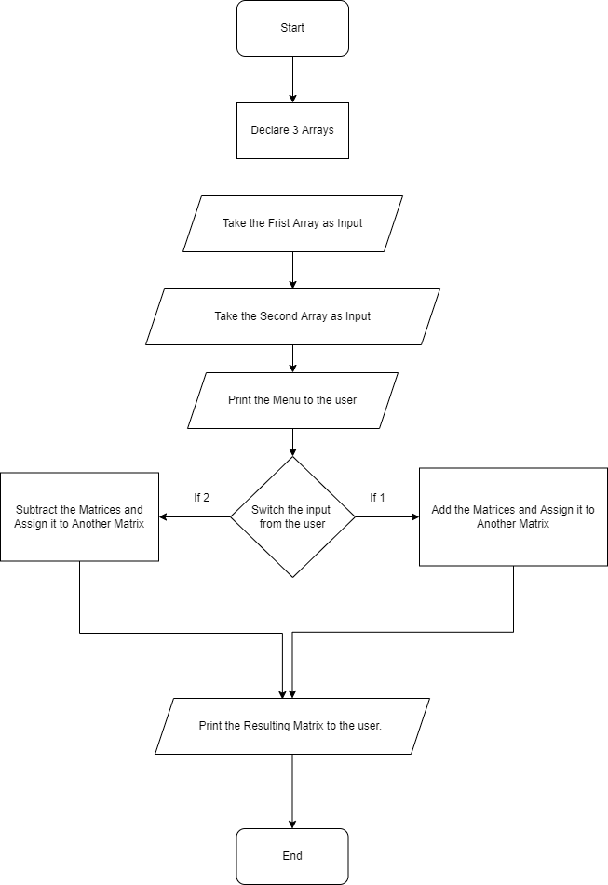

# CODE:

// Write a C program to compute the factorial of a given number using

recursion.

#include<stdio.h>

double factorial(int number)

{

    if(number == 1)

        return 1;

    return number * factorial(number - 1);

}

int main()

{

    int a = 0;

    printf("Enter the number whose factorial you want: ");

    scanf("%d", &a);

    printf("The factorial of the number is: %.1lf", factorial(a));

    return 0;

}

**OUTPUT**

*Addition*

Enter the number whose factorial you want: 5

The factorial of the number is: 120.0

**CONCLUSION:**

The working, concept and implementation of single and multi-dimensional arrays was understood in detail and implemented using switch case in a menu driven program.

**FAQs:**

*Q1. What are the different types of arrays and how do we define them?*

Ans. There are 2 Types of arrays:

1. *One dimensional arrays*
2. *Two dimensional Arrays*

*One Dimensional Arrays:*

They are arrays that have a single subscript.

Syntax: data_type array-name[size]

Multi-dimensional Arrays:

An array having more than one dimensions is known as a multi-dimensional array.

Syntax: data_type array-name[row-size][col-size]

*Q2. How are arrays initialized and processed?*

Ans. Initialization (static):

int matrix[2][2] = {

{1, 2}

{2. 3}

}

Initialization (dynamic):

int matrix[2];

matrix[0] = 1;

matrix[1] = 2;

*Q3. How are elements accessed in a 2D array?*

Elements in a 2-dimensional array are accessed using row and column indices.

For eg.

M = {{1, 2}

{2, 3}}

M[0][1] = 2;

This shows that the element in the 1nd row and 2nd column is 2.